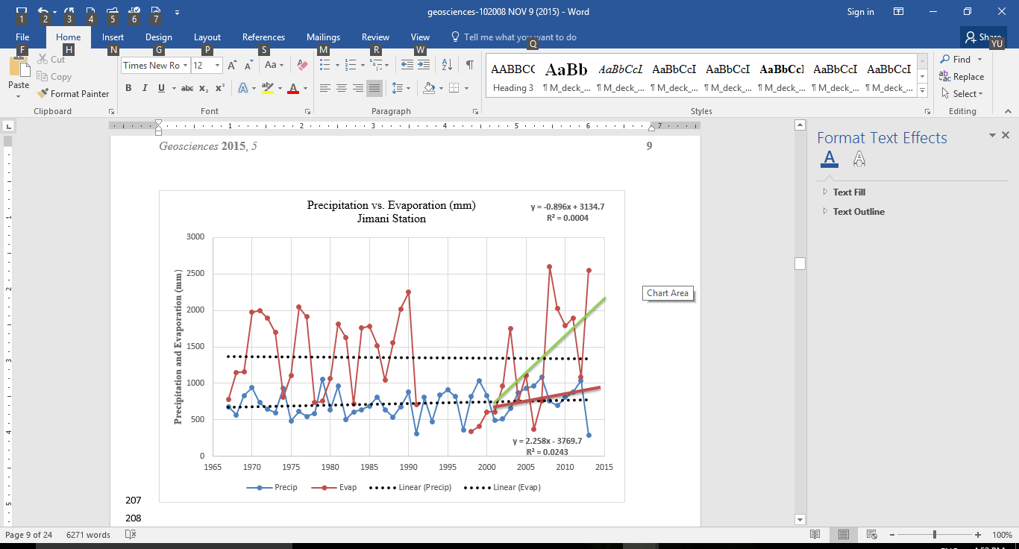

*Figure 2.* Precipitation *versus* evaporation at Jimaní station (Lat: 18.29°N  Lon: 71.51W  Alt: 31.0 m). The complete series shows a slight tendency towards an increase in evaporation and a reduction in precipitation in the region; however, from the year 2000, both precipitation (red) and evaporation (green) increase. The rate of increase is much greater for evaporation than for precipitation. Source National Meteorological Office (ONAMET Spanish acronyms) and Hydraulic Institute Dominican Republic (Spanish acronym INDRHI) region (Méndez-Tejeda et al., 2016).