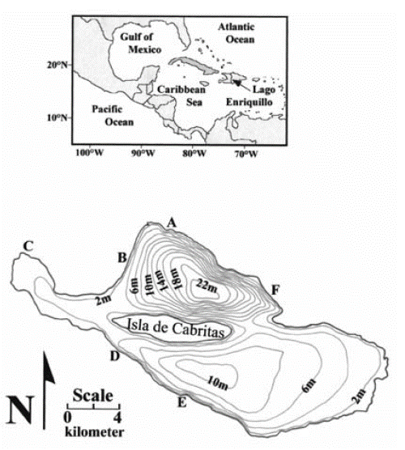

**Figure 1.** Map showing the location of Lake Enriquillo on the Caribbean island of Hispaniola. Bathymetric map of Lago Enriquillo showing 2-m depth contours (modified from Araguás-Araguás *et al.*, 1993). Letters along the shoreline indicate the approximate location of springs mentioned in the text: (A) La Azufrada, (B) Borbollones, (C) Boca de Cachon, (D) Caoba, (E) La Zurza, (F) El Guayabal. Source ( Buck et al., 2005).