CD came

y

‹

light

pro ector

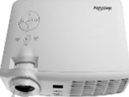

„

-

•

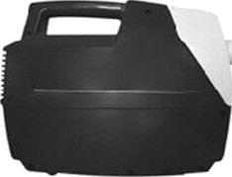Flow pressure control sensor valve BMP180

Arduino

optical rail



spectrophotometer USB4000

with optical fiber

chamber

piezoelectric nebulizer